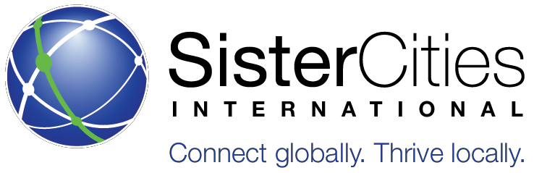
Annual Young Artists Showcase Guidelines

2019 Theme: Global Citizens: Resilient Communities
Sister Cities International aims to promote peace through mutual respect, understanding, and cooperation – one individual, one community at a time. This year’s theme is Global Citizens: Resilient Communities.

Resilience refers to how well an individual/community is able to anticipate, adapt, and respond to adversity or challenges. How can internationally engaged future leaders help communities respond to the various global challenges of the 21st century? In what ways does international experience (not just limited to travel abroad) affect an individual or community’s ability to adapt? What are some examples/illustrations of resilience in a global context?

MEDIUM & SPECIFICATIONS
- One (1) piece of artwork will be accepted from each U.S. member community and one (1) from each of their sister cities. Members with multiple entries are encouraged to form their own local competitions and submit the winner to Sister Cities International’s national competition.
- All media is encouraged except for photography. Please submit all photography through the photography challenge.
  - Ex. Oil paint, acrylic paint, watercolor, charcoal, colored pencil, crayon, ink, marker, etching, collage, and more!
- Only two-dimensional (2D), unframed artwork will be accepted. All entries must be supported by matting if applicable.
- Dimensions of the art and matting must not exceed 24 in. x 36 in. (61 cm. x 91 cm.).
THE WINNING ENTRY FROM THE LOCAL
COMPETITION SHOULD BE SENT TO THE SCI OFFICE BY APRIL 1, 2018:
Sister Cities International, Young Artists Showcase, 915 15th Street NW, 4th Floor, Washington, DC 20005
More information:
www.sistercities.org/YAAS | youth@sistercities.org
Students must be between 13 and 18 years of age at the time of the 2018 deadline.
The student must be affiliated with a dues-paying member of Sister Cities International or an international community with a dues paying sister city.
All entries must meet the criteria listed above, or will be ineligible and returned to the artist.
All entries must conform to Sister Cities International’s policy on plagiarism found at sistercities.org/YAAS.
Individual entries should be sent to your local sister city organization. Contact your local sister city representative for local deadlines.
All final entries must be submitted with a completed entry form postmarked by APRIL 1, 2018.
•
•

•
•
•

•
ELIGIBILITY

AAWARDS
- All artists’ work will be published to Sister Cities International’s website
- One (1) U.S. artist and one (1) international artist will be selected as Grand Prize Winners.
- Each Grand Prize Winner will receive $1,000 cash!
- Five (5) U.S. and five (5) international finalists will be selected.
- All winners’ artwork will be displayed at the 2019 Annual Conference in Houston, TX.
- After the conference, the artwork will go on a tour to select cities across the U.S.
There is NO FEE to enter the Young Artists Showcase.
The return fee is $25.00 per piece of art (only if the artist/program would like the art returned).

Annual Young Artists Showcase Entry Form
SCI members should send Winning Entries from Local Sister City by APRIL 1 to:
Sister Cities International, Young Artists Showcase
915 15th Street NW, 4th Floor, Washington, DC 20005
More information:
www.sistercities.org/yaas |youth@sistercities.org
*Individual entries should be submitted to your local sister city organization by the local deadline.

GLOBAL CITIZENS: RESILIENT COMMUNITIES

Please print clearly in English and enclose this form with the artwork

****NEW DEADLINE****: SUBMISSION MUST BE POSTMARKED BY APRIL 1, 2019 **** NEW DEADLINE****
Title of Artwork
Mailing Address (Street, City, State, Zip Code, Country)
E-mail Address
Phone Number
Full Name (First, Last)

/ /
Birth Date (MM/DD/YY) Gender
Artist Information:
How did you hear about YAAS?
Sister City Program Address (Street, City, State, Zip Code, Country)
E-mail Address
Phone Number
Sister City Contact Person
Sister City Program Sponsoring the Entry
Sister Cities Member Sponsor Information:

Please tell us what inspired you to create this work. Continue on another sheet of paper if you need more space.

Signature of Parent/Guardian
Date
Signature of Artist
Date
Artist’s Waiver

I understand that all showcase entries become the artistic property of Sister Cities International. Although the artist retains his/her copyright for other uses, Sister Cities International will retain perpetual, non-exclusive rights to use submitted artwork in any future publication, promotional material, and/or online service with no compensation other than credit with the artist’s name and community. Sister Cities International takes no responsibility and will not compensate for any lost or damaged artwork.

By submitting this entry, I agree to give Sister Cities International, its members and affiliates permission to publish and display the submitted entry at public exhibits, online, in publications and/or in promotional materials, at the discretion of Sister Cities International. I agree to abide by all the rules and terms of the showcase and
agree to waive all claims of any kind against the showcase organizers.
Would you like the artwork returned?
- NO, I hereby donate my artwork to Sister Cities International to sell as an item at its Annual Conference silent auction.
- YES, I would like my artwork returned. An additional $25 return fee is included with this entry form.

If the art is to be returned, please indicate below the recipient’s address. P.O. Boxes cannot be accepted by the mail service.
The return address is:

